Template for Evidence(s)
UI GreenMetric Questionnaire

University : ...
Country : ...
Web Address : …

[7] Governance and Digitalization
SAMPLE

[7.6] Sustainability Report (GD.3)

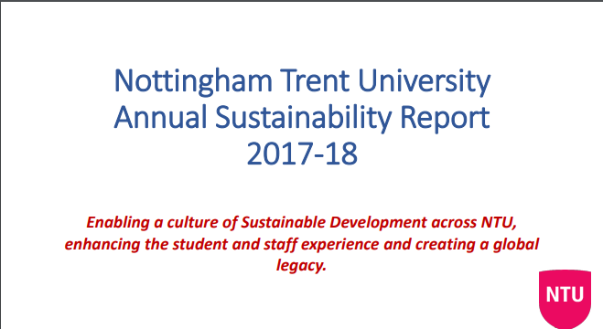 | 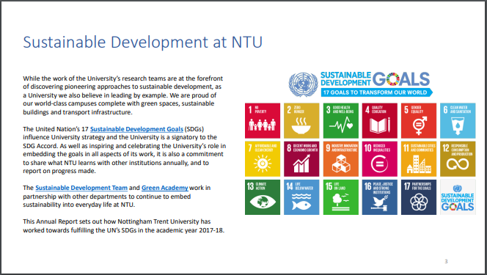
Examples of sustainability report (Nottingham Trent University, UK)
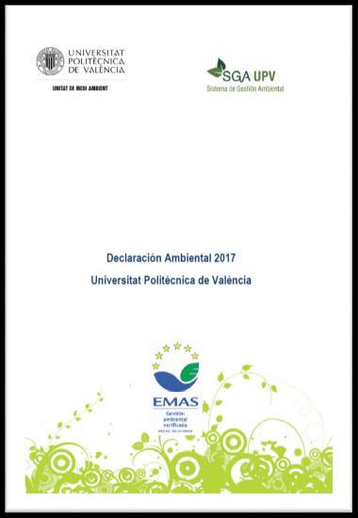
Examples of sustainability report (Universitat Politècnica de València, Spain)

Description:
(The following is an example of the report link/url)
Annual regularity should be proven at least for the last 3 years

Complete text of Universitat Politècnica de València Environmental Statement Report 2017 available on this link: https://riunet.upv.es/handle/10251/101683

Additional evidence link (i.e., for videos, more images, or other files that are not included in this file):

